SCUBA-2 Block Specification
Fibre_tx

September 28, 2005
Table of Contents

1. Block Overview 3
1.1 Block Location and Block Interface Within System 3
1.2 Block Functionality / Features 3
1.3 Dataflow Block Diagram 3
2. Block Interfaces 4
2.1 Interface Signal Description 4
2.2 Interface Protocol and Timing 4
3. High-Level Description 6
3.1 Controller ASM Chart 6

Block Overview

Block Location and Block Interface Within System
This block implements the interface to the Hotlink fibre-optic communication link. It is used on the clock card and connects to the reply_translator module inside issue_reply.

Block Functionality / Features
This block implements a 32-bit interface, giving the appearance of a 32-bit wide communications link when in fact the physical layer is only 8-bits wide. In addition, the block implements a clock domain crossing by using a dual-clock FIFO. Finally, this block implements an asynchronous handshaking protocol to control the flow of data, thus ensuring that the FIFO is not written to when full.

Dataflow Block Diagram

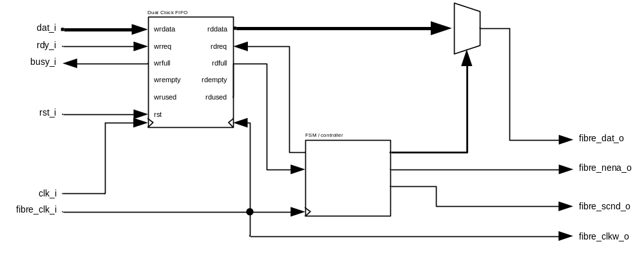

Block Interfaces

Interface Signal Description
- Interface Signals
Signal | Description | Direction
Global Signals
clk_i | Global clock. | in
rst_i | Global reset. | in
Host Interface Signals
dat_i | 32-bit data to be transmitted over Hotlink. | in
rdy_i | Data ready signal. Indicates that the data on dat_i is valid. | in
busy_o | Data busy signal. Indicates that fibre_tx cannot accept data at this time. | out
Fibre Interface Signals
fibre_clk_i | 25 MHz fibre clock. Generated by system PLL. | in
fibre_clkw_o | 25 MHz Hotlink write clock. | out
fibre_data_o | 8-bit data to be sent over Hotlink. | out
fibre_scnd_o | Special character flag. Not used. Tied to ground in this implementation. | out
fibre_nena_o | Hotlink transmitter enable. Indicates that data on fibre_data_o is vaid. | out

Interface Protocol and Timing
Fibre Data Byte Ordering
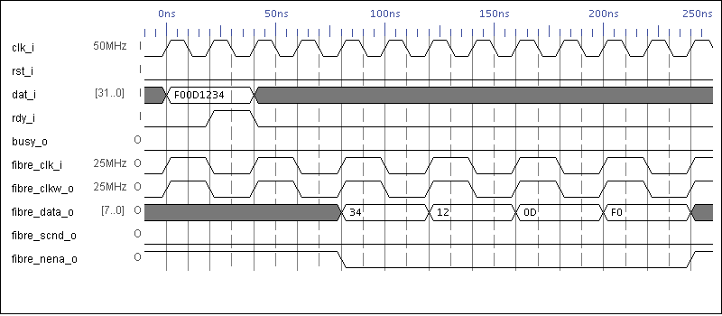

Busy Signal Timing
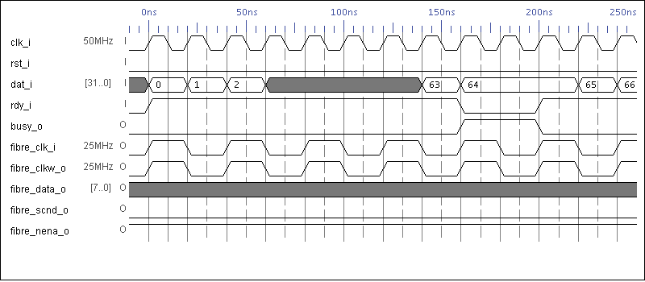
Consecutive Fibre Word Transmission Timing
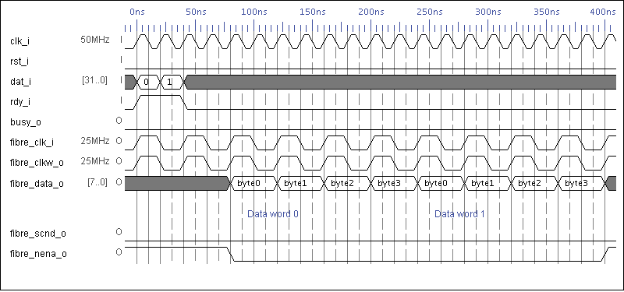

High-Level Description

Controller ASM Chart

fibre_nena_o

fibre_data_o = buffer(7:0)

fibre_data_o = buffer(15:8)

fibre_data_o = buffer(23:16)

fibre_data_o = buffer(31:24)
buf_empty
buf_read
buf_read
buf_empty
send_byte3
send_byte2
send_byte1
send_byte0
idle
T
F
T
F

